MEMORANDUM
Development of an Assistant Application to Identify Off-Road Glances with Eye Data Collected by the SMI Eye Tracker System

DATE: | 08/08/2011
TO: | Marvin Dainoff
FROM: | Yulan Liang, Luci Simmons, Jake Banks, Angela Garabet, Bill Horrey

This assistant application presents part of an effort devoted to data reduction for project LMRIS 10-09. The objective of this project is to investigate drivers’ adaptive behavior in secondary task engagement under different driving demands. Engaging in a secondary task was signified by drivers’ off-road glances to an in-vehicle interface, and therefore accurately identifying drivers’ glances was essential for this project. To obtain reliable information of drivers’ glance behavior, we developed this application that allows researchers to visually identify/examine glance behavior of drivers especially when the eye tracker system fails to track the driver eye. The use of this application is not limited to this project, but can be generalized to other studies, in which eye glances are the behavior of interest and eye tracking quality is not ideal.

In this document, we first describe the SMI eye tracker system and the normal data collection and data reduction procedure with the system. Then we discuss several issues that we encountered and elaborate how we solved these issues with a customized application.

SMI eye tracker system has two software packages: iView and BeGaze. The iView software is designed to regulate data collection, and BeGaze is for post processing of data, including identification of eye glances in specified areas of interest (AOIs). The SMI system hardware includes two video cameras mounted on the brim of a baseball cap. One camera captures the video of the subject’s view. We refer to this as the scene camera and call the video it records the scene video. Another camera captures the image of the subjects’ right eye obtained via a reflective mirror. We refer to this as the eye camera and call the video it records the eye video. From each frame image of eye video, the iView software can identify the center of the pupil and corneal reflex (CR) and then uses this information to calculate the direction of subject’s gaze after a successful calibration procedure has been completed. Therefore, it is important for the equipment to accurately identify the pupil and CR throughout calibration and data collection to secure good tracking. When tracking is good, iView overlays a cursor representing the subject’s gaze onto the scene video in real time.

For optimal data collection, the instrumented baseball cap is fitted securely so that the scene camera and eye camera do not move relative to the head of a subject. The eye tracker is then calibrated as the subject looks at five pre-defined locations located in a vertical plane ahead of them. After data collection has begun, the iView software records the scene video with gaze overlay. Binary data that indicates the gaze direction in the scene are collected and can later be converted to a text data file. When data collection is complete, the scene video and binary dataset are saved using the same name (with different extensions) to aid in post-processing.

During data reduction, researchers can use the BeGaze software to identify glance behavior if tracking quality is good. BeGaze allows researchers to define and adjust multiple AOIs in the scene video frame by frame, then automatically recognizes whether the gaze fell in these AOIs, and output this information into a text formatted dataset. For project LMRIS 10-09, the in-vehicle interface was the AOI, and the goal of data reduction was to identify when drivers looked to this AOI and when they focused on the driving task.

The above describes the ideal scenario of eye data collection and reduction, which was not efficiently supported by the current SMI eye tracker. We encountered several issues in data collection and post data reduction. First, tracking quality was low for some participants. We found that 31% of trials had a tracking rate below 80%, 31% of trials had a rate between 80% and 88%, and only 38% of trials had a rate above 89%. A rate below 80% means that it is almost impossible to use BeGaze to code off-road glances. A rate between 80% and 89% suggests that coding is challenging but feasible for some/parts of trials. A rate above 89% indicates that coding is feasible and relatively consistent throughout trials. This low tracking quality was caused by various factors, such as the large distance participants needed to move their eyes between the road ahead and the in-vehicle interface. Some physical features of drivers’ eyes made it hard for the eye tracker to recognize the pupil and corneal reflex (CR), such as long, dark eye lash and either too small or too large eyes. Other causes are summarized in Appendix A.
Glossary
Scene Video: Video of the drivers’ view of the roadway and vehicle interior. The eye tracking software collects this video automatically and then superimposes a cursor representing the participants’ gaze when the system is functioning optimally.
Eye Video: Video of the participant’s right eye with cross cursors representing the centers of pupil and CR overlaid. This is not automatically collected by the system but we have found a way to manually initiate recording of the video once the scene video has been initiated.
Eye Data: “Raw” numeric data collected automatically by the eye tracking software and output in text format.

Other problems include the fact that BeGaze does not allow AOIs extending outside the image of scene video. That is, when a proportion of the in-vehicle interface was outside the scene video and the driver was looking at that proportion of the interface, we could not enlarge the AOI beyond the boundary of the video to capture this off-road glance. In addition, BeGaze does not provide the flexibility to manually identify eye glances because the software does not display real-time eye data. When bad tracking or glances beyond the scene video occurs, the system fails to produce reliable eye glance measures.

One way to solve these issues is to use a combination of the eye and scene videos. That is, we can manually code off-road glances by examining drivers’ head movements and relative eye angle. However, iView does not record the eye video automatically with scene video and eye data (and therefore it is not synchronized), and BeGaze does not allow us to view scene video, eye image, and eye data at the same time.

Thus, we decided to develop a customized application to fit the specific needs of this data reduction. The objectives of this application were to facilitate the synchronization of scene video, eye video, and eye data to allow us to code off-road glances (to the in-vehicle interface) manually based on the simultaneous viewing of the three sources of information.

Application Design

The basic functions of this application include:
1) Synchronizing eye video, scene video, and eye data
2) Simultaneously browsing video and eye data frame-by-frame/line-by-line
3) Identifying the start/end of drivers’ glances to the in-vehicle interface and inserting them as values in the eye data.

Figure 1 illustrates common factors of the eye video, scene video, and eye data. Scene video and eye data are collected at 25 Hz and 50 Hz, respectively. These two pieces of data are collected simultaneously, but because of frame dropping issues, they are not matched exactly 1:2 over time. The link between the two sources is a variable in the data named “frame” which indicates the matched frame number in the scene video for the corresponding line of the eye data (double arrow line in Figure 1).
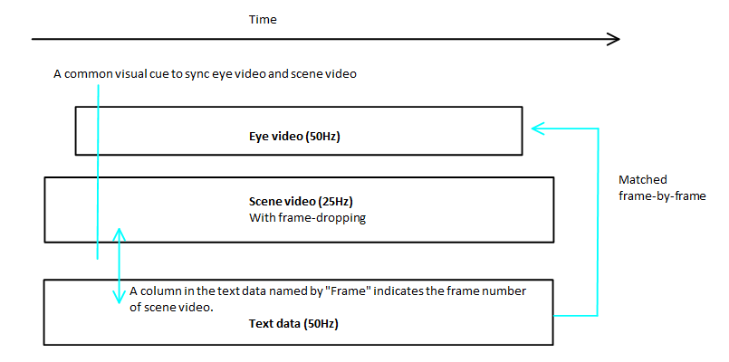
Figure 1. Relationship/links between eye video, scene video, and eye data

Eye video is collected independently, illustrated by the smaller box in Figure 1. Since there is no embedded link among the three sources of data, we needed to create a common visual cue in both the eye video and scene video to act as a point of alignment (straight line in Figure 1). Also, the eye video is collected at 50 Hz, and each eye image is used to calculate the location of gaze and form a line of data in the eye data file. Thus, we assume that eye video and eye data are matched with each other frame by frame (single arrow line in Figure 1).

Based on these links, the calculation of drivers’ eye glances could be implemented in a two-step procedure. Step one was to align the eye video and scene video based on the common visual cues so that three sources of data could be synchronized. Step two was to advance the eye video/eye data frame-by-frame/line-by-line to identify the start and end of each off-road glance.

First, we created a common visual cue in both eye video and scene video. We asked participants to simultaneously use a “screen” to block the scene camera and to close their eyes for several seconds at the beginning of each experimental trial. Participants then removed the “screen” and opened their eyes simultaneously. The first frame in which the eye tracker began to track the participants’ eye was used as the common cue to synchronize the two video streams i.e. the point at which the centers of the pupil and corneal reflection are first identified in the eye video, and the point at which the gaze cursor first appears in the scene video. By using this common point, the eye data can be aligned with the video sources using the frame number of scene video. The data can then be advanced and the eye video utilized to define the transition of participants’ eyes back and forth between the roadway and in-vehicle interface. Scene video can be used to view head and eye movements (eye movements only appear in the scene video when tracking is good), helping to specify the direction of the eyes. Once an off-road glance is identified, the start and the end of the glance can be marked in the eye data so that glance duration and other glance behavior measures and be calculated at a later time.

Application Development

The application was implemented in LabView by Jake Banks. Figure 2 shows the interface used to synchronize data. The top and bottom horizontal bars (“1” in Figure 2) can navigate through scene video and eye video in frame-by-frame fashion independently, and the text boxes next to the bars indicates the frame numbers of the current view in the video. After locating the alignment point in both videos based on the common visual cue, we press the “Align” button (“2” in Figure 2). The application then changes to the interface for drivers’ eye glance coding (Figure 3).

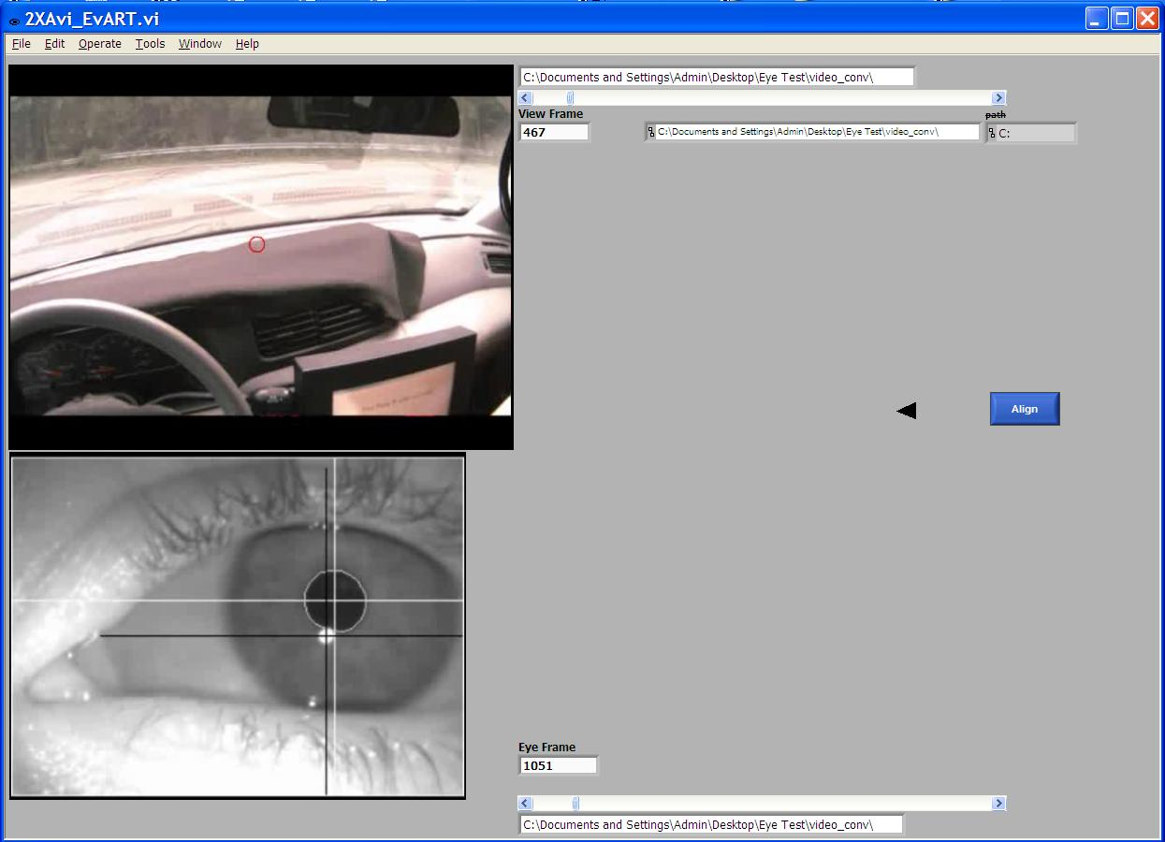
1
1
2
Figure 2. The screenshot of data synchronization

After data are synchronized, the eye data is displayed in a spreadsheet format at the right of the interface (rectangle in Figure 3). The black arrow (“1” in Figure 3) indicates the data line that the displayed video images illustrate. This data line is identified based on the frame number of scene video at the alignment point after pressing the “Align” button. The eye data can now be advanced line by line as the eye video advances frame by frame. The eye video is navigated by moving the horizontal bar at the bottom (“2” in Figure 3), and the scene video image is determined by the frame number specified in the “frame” column in the eye data. Three buttons at the lower right (“3” in Figure 3) are used to mark the start and end of off-road glances. Upon completion of coding the “stop” button (“4” in Figure 3) is used to save and close the data file.

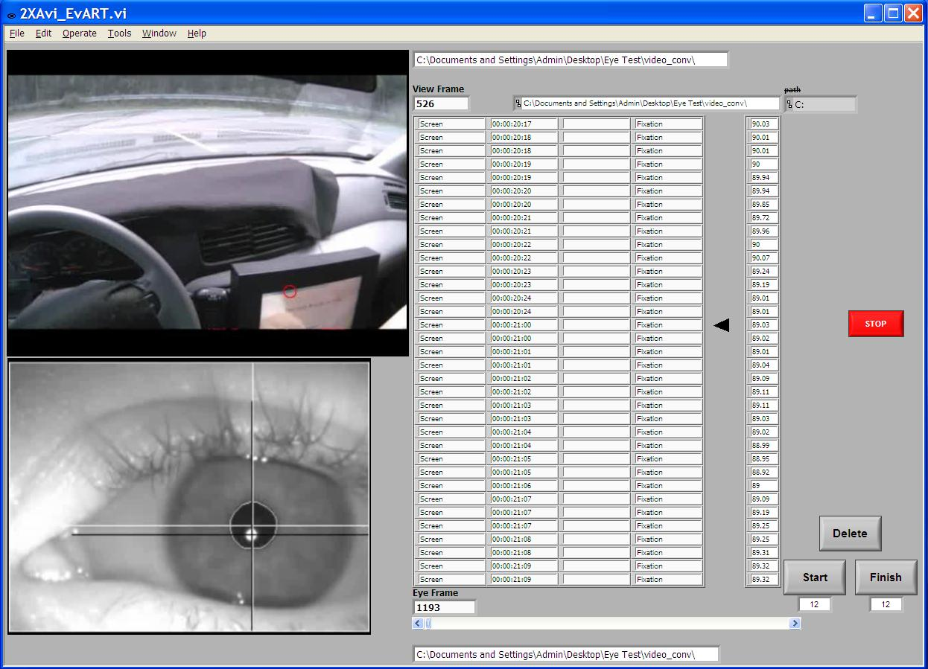
1
2
3
4
Figure 3. The screenshot to code drivers’ eye glances

Limitations of the application and desired function for SMI software

There are some limitations of this application:
- There is frame-dropping in the eye video, such that the video does not always match with the eye data precisely. When the frame drop occurs, the eye video becomes frames ahead of the scene video and eye data, and the drop rate varies across different trials. Fortunately except for a few cases, this frame-dropping was not observed too often in an experimental trial, and the manual nature of the coding means that these errors can be dealt with on a case by case basis. When the mismatch occurred, we almost use eye video to identify glances since it was more convenient and the error was usually not big.
- Aligning the videos and data at the beginning is time consuming step and requires a lot of detailed adjustments. Sometimes it even needs a second alignment to make sure that data are synchronized accurately. The length of time on this step is expected to be reduced as reductionists get more practice.
- This application can be used only when AOIs (forward road and in-vehicle interface in this project) can be easily differentiated. In this study, drivers typically moved their gaze between the forward road and the in-vehicle display. The visual angle between these two AOIs is large even with the compensation of head movements. Therefore, human reductionists are able to identify which AOI drivers viewed. When multiple AOIs are specified or distance between AOIs is small, identify glances solely with the eyes of reductionists will be challenging.

A few desired functions for SMI software:
- In data collection, there would be an option to collect eye video simultaneously with scene video and eye data to save the time-consuming synchronization step.
- In the post data reduction, there should be a way to view eye video, scene video, and eye data together, similar to Figure 3. The software would also be able to recalculate gaze location for the instances where tracking was lost during data collection if the centers of pupil and CR can be manually defined/redefined in data reduction. Also users should be able to define multiple AOIs (already in BeGaze), and these AOI areas should go beyond the view that the scene camera captures.

Appendix A
Some experience we gained on the SMI eye tracker during data collection for LMRIS 10-09 and suggestions for future studies that require collecting eye data

- Dynamic tracking was always used.
- For driving studies, we should adjust the angle of the scene camera downward during calibration/data collection so that the (insignificant) upper portion of the road view is eliminated and the (critical) area of the touch screen is included.
- It is critical to monitor effectiveness of tracking and accuracy of calibration throughout the experiment. Recalibrating periodically produced significantly higher tracking rates.
- For a long protocol, screening subjects with poor tracking prior to their experimental session may be advantageous. Suggest inclusion of a “discontinuation of participant due to poor tracking” paragraph.
- There does not seem to be a way to predict a participant’s potential tracking quality until the eye tracking equipment is fitted and calibration is attempted.
- Factors affecting tracking include:
  - Length and thickness of eye lashes – thicker eyelashes or those with mascara interfered with the recognition of the pupil. Sometimes adjusting the bounds of the eye image allowed removal of the densest areas of lash from analysis by the system. Increasing pupil density in rejection may help a little bit, but not much. Using an eye lash curler was not attempted but may reduce the impact of thicker or longer lashes on pupil recognition.
  - Surface area of the eye obscured by the eyelid while looking forward – sometimes there was too little of the eye showing, resulting in the system having difficulty recognizing the pupil. Sometimes the profile of the eye resulted in large or multiple CR’s. Adjusting the tracking parameters (particularly rejection parameters e.g. reflex perimeter maximum) is beneficial.
  - Surface area of eye obscured by eyelid while looking downward – this was the most problematic. There was often a trade-off between recognition of the eye in forward versus downward gaze. Adjusting the tilt of the mirror to a more horizontal angle underneath the eye allowed less interference from lashes but then resulted in problems with CR recognition. A more vertical angle improved the CR recognition in the forward gaze but allowed more interference from lashes when the subject viewed the touch screen.
  - Consistency of viewing/head angle - some subjects altered their head tilt, eye position etc. while driving so that even if calibration was successful, tracking % was low during driving due to the adjusted/adjusting of position.
  - Ability to secure cap on subject’s head – for those subjects with thicker and looser hair it was difficult to keep the cap from slipping around and producing a need to recalibrate or discontinue.

